CURRICULUM VITAE
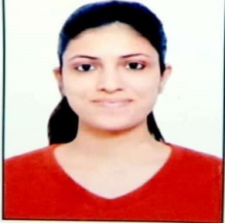
  - Name: Rajnee Devi

E-Mail: drajnee.philo@gmail.com

Vision
My vision is to work with creativity and insight with good Academic Institution in the areas of Teaching, Research and Development for the betterment of self and others. To help students improve their learning and reflective capacity by sharing my knowledge and experiences with more interactive and engaging sessions.

Academic Qualification and Achievements

ICPR-JRF
UGC NET

PhD (pursuing)
2021
Department of Philosophy, University of Delhi (DU)

MPhil (Master in Philosophy)
2021
Jawaharlal Nehru University (JNU)
Dissertation Title: “The Experiential Dimension of Consciousness: A Study of Dan Zahavi’s Notion of Selfhood”

M.A (Philosophy)
2017
Indraprastha College for Women,
University of Delhi

Conference and Paper Publications
- Paper Presented at 94th session of Indian Philosophical Congress (IPC), held at NEHU, Shillong during 9-11 March, 2020.
“Exploring Truth in Narrativist and Non-Narrativist Account of Self.”

- Paper Presented at 3rd World Conference of Logic and Religion (WoCoLoR), held at IIT BHU Varanasi, UP during 04-08 November, 2022.
“Self and Consciousness: An Attempt at Bridging the Gaps between the East and the West.”

- Research Paper published in a peer-reviewed Journal: Journal of Comparative Literature and Aesthetics (JCLA) vol. 43.3 winter 2020.
“Existential Traits in Hermann Hesse’s Siddhartha: An Ontological Inquiry.”

- Research Paper published in a peer-reviewed Journal: Journal of Darṡana (ISSN 2348-0122) vol XIII-XVI, “Investigating the Pure-Consciousness with a Special Reference to the Linguistic Analysis of Bhartrhari”, pp 83-93.

- Research Paper published in a peer-reviewed Journal: Journal of Applied Research in Humanitis, Languages, and Social Sciences (ISSN:2583-2999), vol-2, issue no. 2, April 2023, “Conditional Comittment in Shared intention”, pp 41-50.

